Northern Postgraduate Chemical Engineering Conference 2013 |  |  | 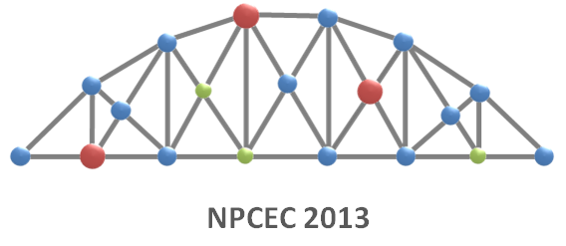
REGISTRATION FORM
Thank you for your interest in attending the NPCEC 2013. If you wish to attend or present, please fill out this form and e-mail it as an attachment to npcec2013@ncl.ac.uk
Personal Info
First Name:
Surname:
University / Organisation:
E-mail address:
Conference Info
Do you wish to present at the conference? |  | Yes No
Type of Presentation: |  | Oral Poster
Title of Presentation:
Presentation Category:  (Please select one only) |  | Energy Biomedical Engineering  Food & Agro Product Engineering  Biotechnology Bioreactor Engineering  Analytical Technologies Separation  Renewable Energy Advanced Materials  Modelling & Simulation Process Intensification  Heat Transfer Crystallisation
 |  | Other (please state)
Food & Social Activities
Food Requests: |  | Vegetarian Vegan Allergies Other
If Allergies or Other, please state:
Attending Social Dinner*: |  | Yes No
*note: social programme to be announced. This will be partially or fully subsidised by the conference organisers. Full details to follow.
Thank you for your time in filling out this form.
We look forward to seeing you at the conference.

